Title of Your Mini Lab Project

Submitted By

Student Name | Student ID
Student-1 Name | Student-1 ID
Student-2 Name | Student-2 ID
Student-3 Name | Student-3 ID
Student-4 Name | Student-4 ID
Student-5 Name | Student-5 ID

MINI LAB PROJECT REPORT
This Report Presented in Partial Fulfillment of the course CSEXXX: Subject Name in the Computer Science and Engineering Department



DAFFODIL INTERNATIONAL UNIVERSITY
Dhaka, Bangladesh
November 2, 2024

DECLARATION
We hereby declare that this lab project has been done by us under the supervision of Name of the course teacher, course teacher’s Designation, Department of Computer Science and Engineering, Daffodil International University. We also declare that neither this project nor any part of this project has been submitted elsewhere as lab projects.

Submitted To:

Course Teacher’s Name
Designation
Department of Computer Science and Engineering Daffodil International University

Submitted by

Student Name Student ID:
Dept. of CSE, DIU
Student Name Student ID:  Dept. of CSE, DIU | Student Name Student ID:  Dept. of CSE, DIU
Student Name Student ID:  Dept. of CSE, DIU | Student Name Student ID:  Dept. of CSE, DIU

COURSE & PROGRAM OUTCOME

The following course have course outcomes as following:.

Table 1: Course Outcome Statements
CO’s | Statements
CO1 | Define and Relate classes, objects, members of the class, and relationships among  them needed for solving specific problems
CO2 | Formulate knowledge of object-oriented programming and Java in problem solving
CO3 | Analyze Unified Modeling Language (UML) models to Present a specific problem
CO4 | Develop solutions for real-world complex problems applying OOP concepts while  evaluating their effectiveness based on industry standards.

Table 2: Mapping of CO, PO, Blooms, KP and CEP
CO | PO | Blooms | KP | CEP
CO1 | PO1 | C1, C2 | KP3 | EP1, EP3
CO2 | PO2 | C2 | KP3 | EP1, EP3
CO3 | PO3 | C4, A1 | KP3 | EP1, EP2
CO4 | PO3 | C3, C6, A3,  P3 | KP4 | EP1, EP3

The mapping justification of this table is provided in section 4.3.1, 4.3.2 and 4.3.3.

Table of Contents

Declaration i

Course & Program Outcome ii
- Introduction 1
  - Introduction 1
  - Motivation 1
  - Objectives 1
  - Feasibility Study 1
  - Gap Analysis 1
  - Project Outcome 1
- Proposed Methodology/Architecture 2
  - Requirement Analysis & Design Specification 2
    - Overview 2
    - Proposed Methodology/ System Design 2
    - UI Design 2
  - Overall Project Plan 2
- Implementation and Results 3
  - Implementation 3
  - Performance Analysis 3
  - Results and Discussion 3
- Engineering Standards and Mapping 4
  - Impact on Society, Environment and Sustainability 4
    - Impact on Life 4
    - Impact on Society & Environment 4
    - Ethical Aspects 4
    - Sustainability Plan 4
  - Project Management and Team Work 4
  - Complex Engineering Problem 4
    - Mapping of Program Outcome 4
    - Complex Problem Solving 4
    - Engineering Activities 5

Table of Contents Table of Contents

- Conclusion 6
  - Summary 6
  - Limitation 6
  - Future Work 6
References 6

Chapter 1

Introduction

Every chapter should start with 1-2 sentences on the outline of the chapter.

Introduction
This section should present the background and a problem statement that your project aims to solve.

Motivation
The computational motivation that encourages you to solve the problem should be stated here clearly. In addition, you can mention why solving this problem will benefit you.

Objectives
Enumerate the objectives in clear and specific terms.

Feasibility Study
Put a summary of similar research study, case study, methodological contribution of existing projects, web applications, and mobile apps similar to your work [1].

Gap Analysis
Here summaries the gap where you intend to work.

Project Outcome
What are or could be the possible outcomes of your work?

Chapter 2

Proposed Methodology/Architecture

Every chapter should start with 1-2 sentences on the outline of the chapter.

Requirement Analysis & Design Specification

Overview

Proposed Methodology/ System Design
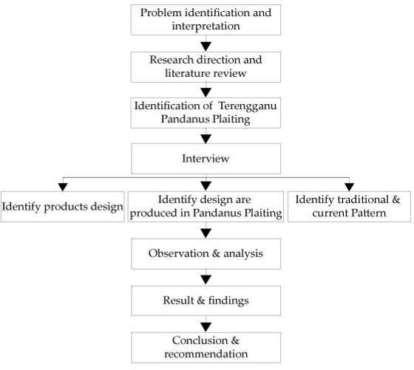
Figure 2.1: This is a sample diagram

UI Design

Overall Project Plan

Chapter 3

Implementation and Results

Every chapter should start with 1-2 sentences on the outline of the chapter.

Implementation

Performance Analysis

Results and Discussion

Chapter 4

Engineering Standards and Mapping

Every chapter should start with 1-2 sentences on the outline of the chapter.

Impact on Society, Environment and Sustainability

Impact on Life

Impact on Society & Environment

Ethical Aspects

Sustainability Plan

Project Management and Team Work
Provide a cost analysis in terms of budget required and revenue model. In case of budget, you must show an alternate budget and rationales.

Complex Engineering Problem

Mapping of Program Outcome
Table 4.1: Justification of Program Outcomes
CO | CO Description | PO
CO1 | Understand software architecture's pivotal role in project success. | PO1
CO2 | Translate customer requirements into effective software designs. | PO3
CO3 | Develop user-friendly frontend components using suitable technologies. | PO4
CO4 | Utilize version control for collaborative software development. | PO4

Complex Problem Solving




Table 4.2: Mapping with complex problem solving.
EP1  Dept of Knowledge | EP2  Range of Conflicting Requirements | EP3  Depth of Analysis | EP4  Familiarity of Issues | EP5  Extent of Applicable Codes | EP6  Extent  Of Stakeholder Involvement | EP7  Inter- dependence

Justification:

- EP1 has been achieved through applying the engineering fundamental and specialized knowledge (K3, K4). We also need engineering design knowledge in this project (K5, K6).

- EP2 has been achieved as we have to consider the design constraints over the backend development in this project.
- EP3 , we need a depth of analysis when we have collected the requirements for our project. It requires thorough analysis what is the UI requirements to ensure the usability of the project.
Chapter 5

Conclusion

Every chapter should start with 1-2 sentences on the outline of the chapter.

Summary

Limitation

Future Work

References

[1] Jon Kleinberg and Eva Tardos. Algorithm design. Pearson Education India, 2006.

